## Task 1: Create SNS Topic

1. Make sure you are in the US East (N. Virginia) us-east-1 Region.
2. Navigate to SNS by clicking on the  menu available under the Application Integration section.
3. Click on Topics in left panel. Click 
4. Select the Type as Standard.
5. Under Details:
   * Name : Enter *mysnsnotification*
   * Display name : Enter *mysnsnotification  
       
     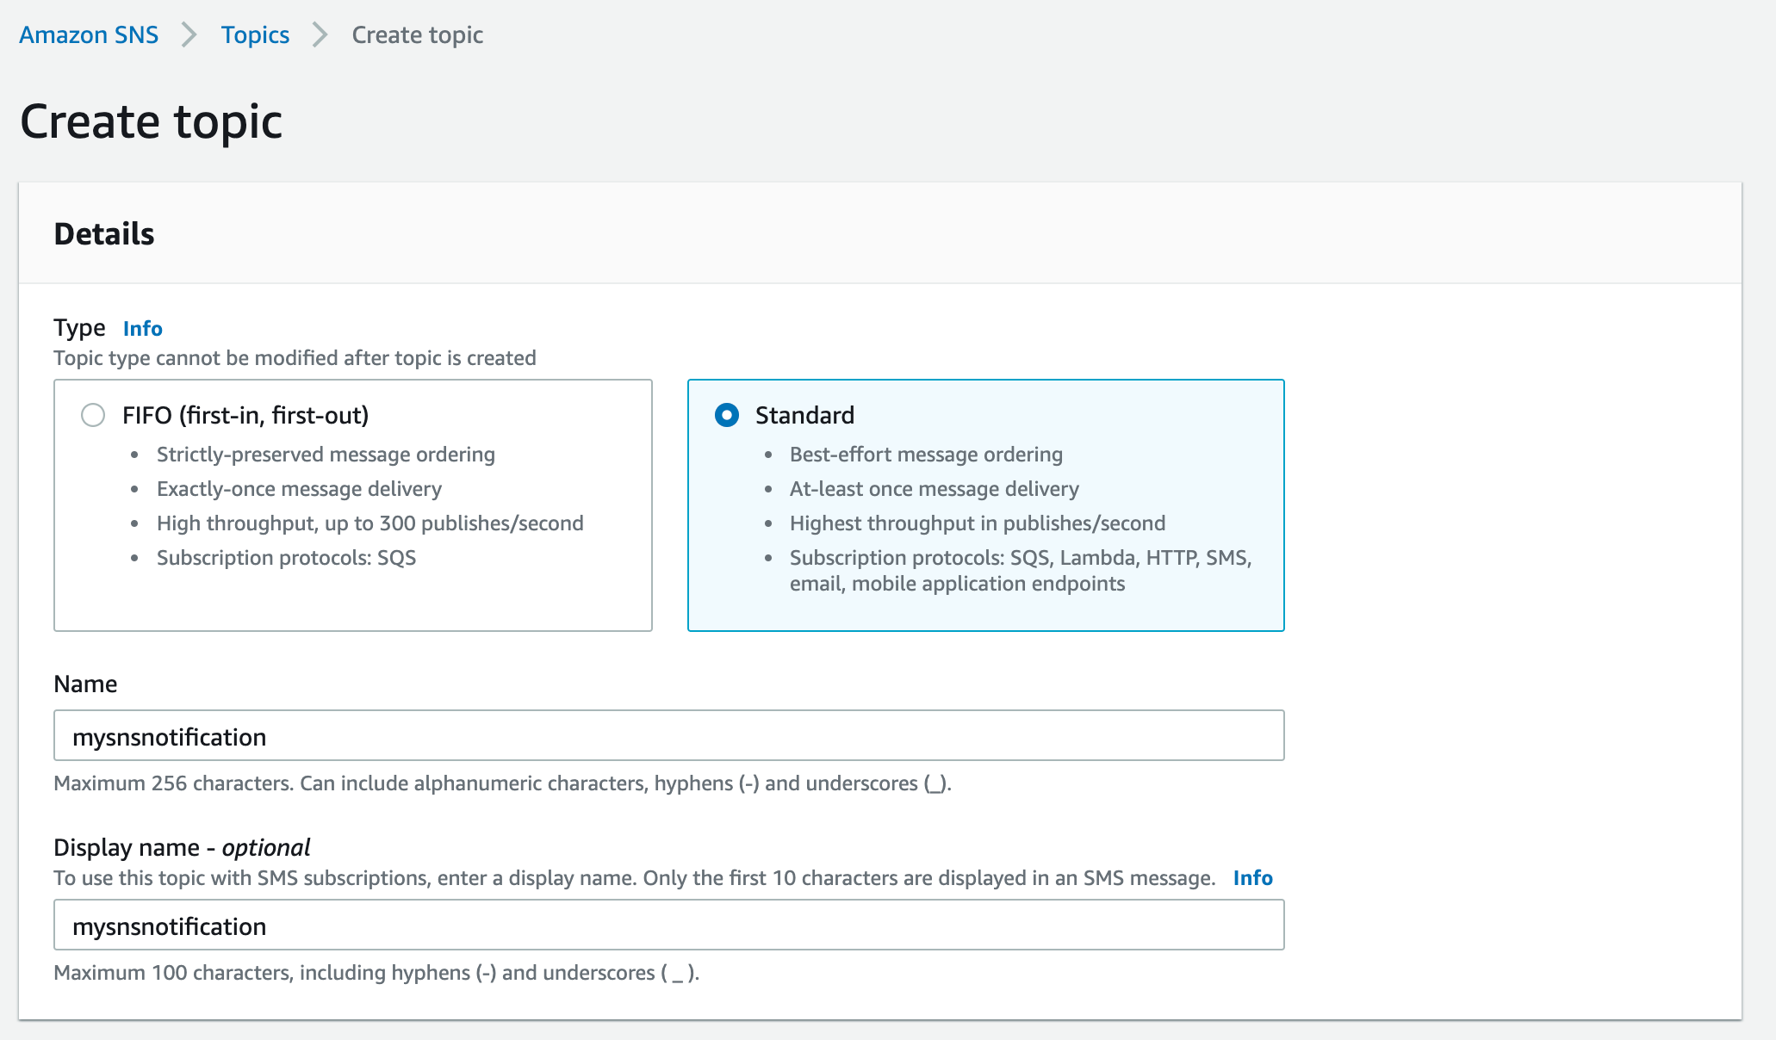*
6. Leave other options as default and click on Create topic.
7. An SNS topic is now created.

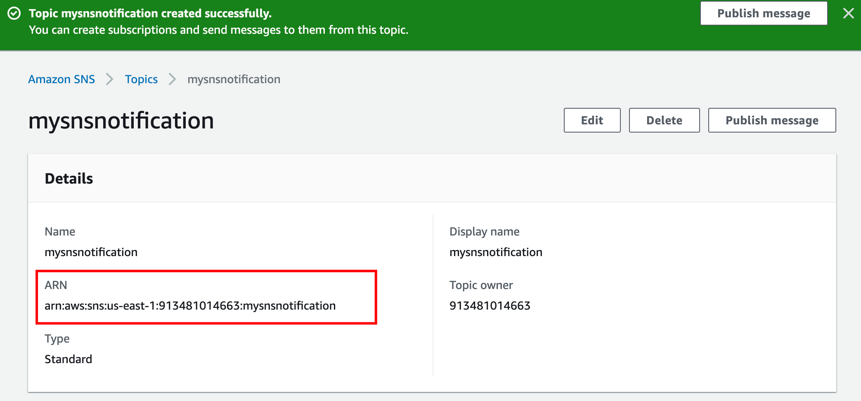

1. Copy the ARN and save it for later.

## Task 2: Subscribe to SNS Topic

1. Once the SNS topic is created, scroll down below and click on *.*
2. Under Details:
   * Protocol : Select Email
   * Endpoint : Enter <your Mail Id>
   * Note: Make sure you give a valid email address as you will receive an SNS notification to this email address.
   * Check your Spam box if you don't see the email in your Inbox.
3. You will receive an email confirming your subscription to your email.

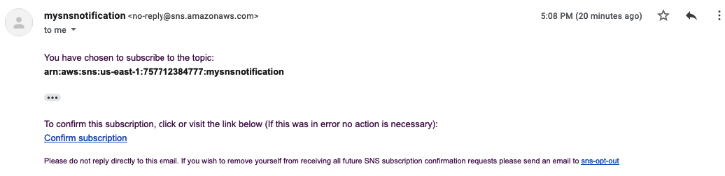

1. Click on Confirm subscription.

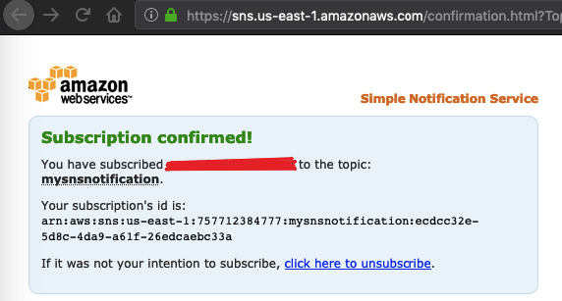

1. Your email address is now subscribed to the SNS Topic mysnsnotification*.*

## Task 3: Create S3 an Bucket

1. Navigate to AWS S3 by clicking on Services at the top left corner. S3 is available under Storage.
2. In the S3 dashboard, click on the  and fill in the bucket details.
3. In the General Configuration:
   * Bucket name: Enter *mys3buckettestingsns-{yourname}*
   * Example : *mys3buckettestingsns-sam*(Note: The Bucket Name must be unique across all existing bucket names in Amazon S3)
   * Region: Select US East (N. Virginia) us-east-1  
     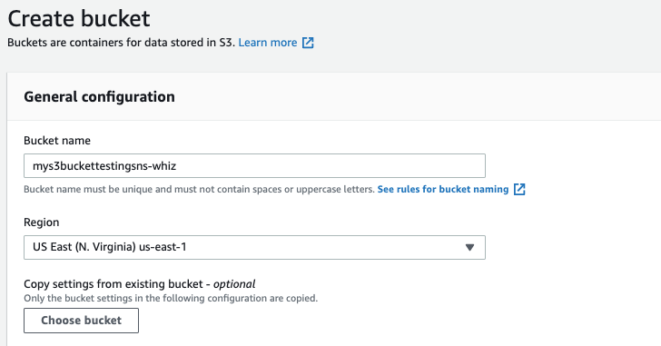
4. Object ownership: Select ACLs disabled (recommended) option
5. Leave all other settings as default and click on Create bucket.
6. Select the created bucket and click Copy ARN on the top. Save the ARN.

## Task 4: Update SNS Topic Access Policy

1. Navigate back to the SNS page.
2. Click on Topics.
3. Click on *mysnsnotification.*
4. Click on Edit at the top right corner to edit the Access Policy of the SNS topic.
5. Expand Access Policy.
6. Update the bucket policy as shown below:

* Note: Here we need to update two things after pasting the below policy.
* SNS Topic ARN in the Resources section below
* S3 bucket ARN in the Condition section below

| {  "Version": "2008-10-17",  "Id": "__default_policy_ID",  "Statement": [  {  "Sid": "__default_statement_ID",  "Effect": "Allow",  "Principal": {  "AWS": "*"  },  "Action": [  "SNS:GetTopicAttributes",  "SNS:SetTopicAttributes",  "SNS:AddPermission",  "SNS:RemovePermission",  "SNS:DeleteTopic",  "SNS:Subscribe",  "SNS:ListSubscriptionsByTopic",  "SNS:Publish",  "SNS:Receive"  ],  "Resource": "<Your_SNS_Topic_ARN>",  "Condition": {  "ArnLike": {  "aws:SourceArn": "<Your_Bucket_ARN>"  }  }  }  ]  } |
| --- |

1. Note: Make sure to update the bucket ARN and SNS topic in the above policy.
2. Click on Save Changes.
3. Now your SNS topic has access to send notification events based on S3 bucket events.

## Task 5: Create S3 Event

1. Navigate back to the S3 page.
2. Click on the S3 bucket that you have created in the above step.
3. Go to the Properties tab and scroll down to Event notifications.
4. Click on .
   * Event name : Enter *myemaileventforput*.
   * Event types : Check PUT  
     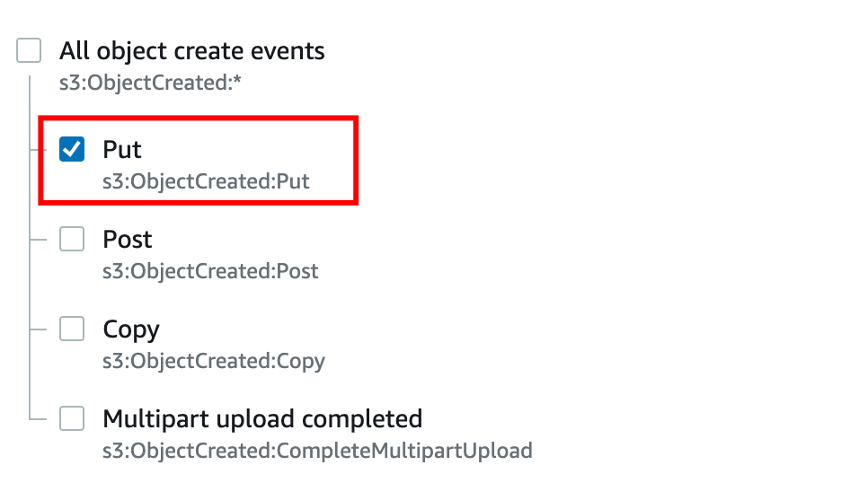
   * Under Destination select SNS Topic
   * Under SNS topic select topic name created earlier.
   * Click on Save changes.  
     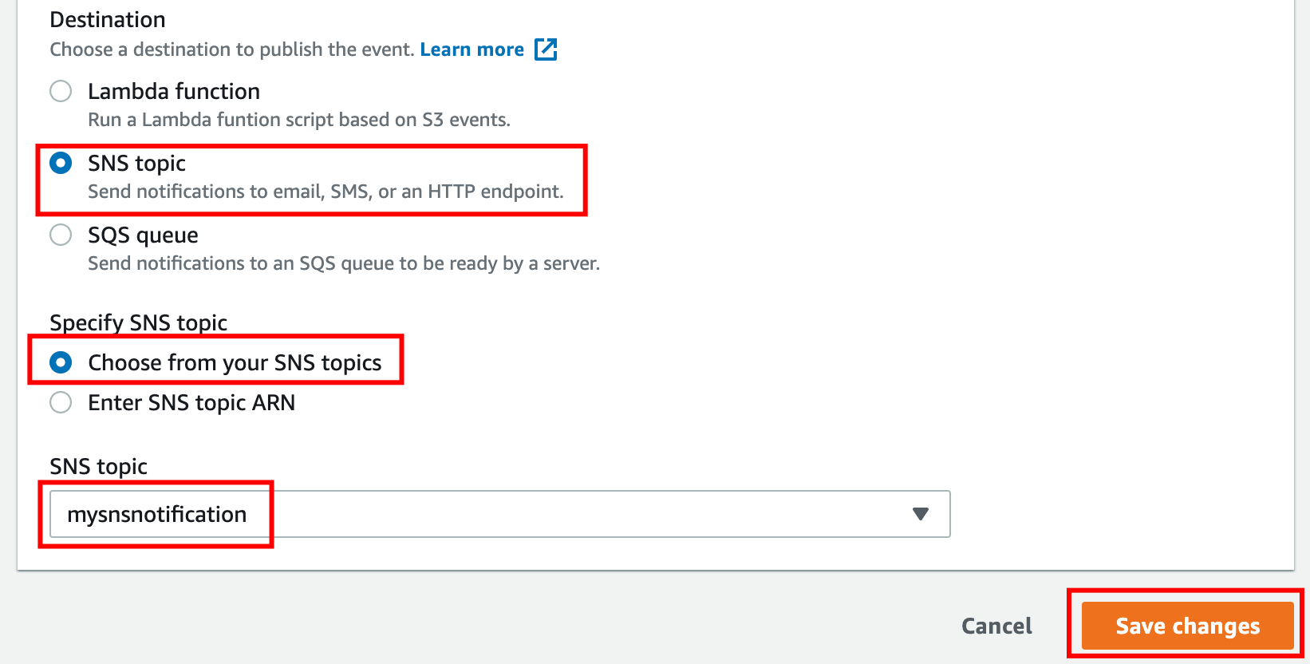
5. Note: If you are getting the below error make sure to check that you have added PUT as condition above and completed Task 5 i.e. Updating the SNS Access Policy.  
   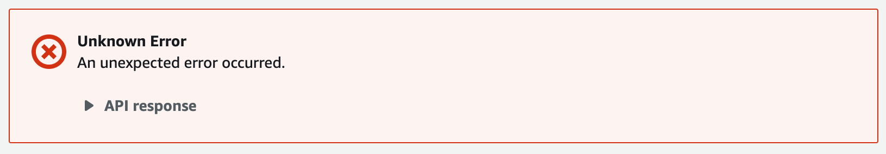
6. Now the S3 bucket has been enabled event notifications for putting new objects through our SNS topic.

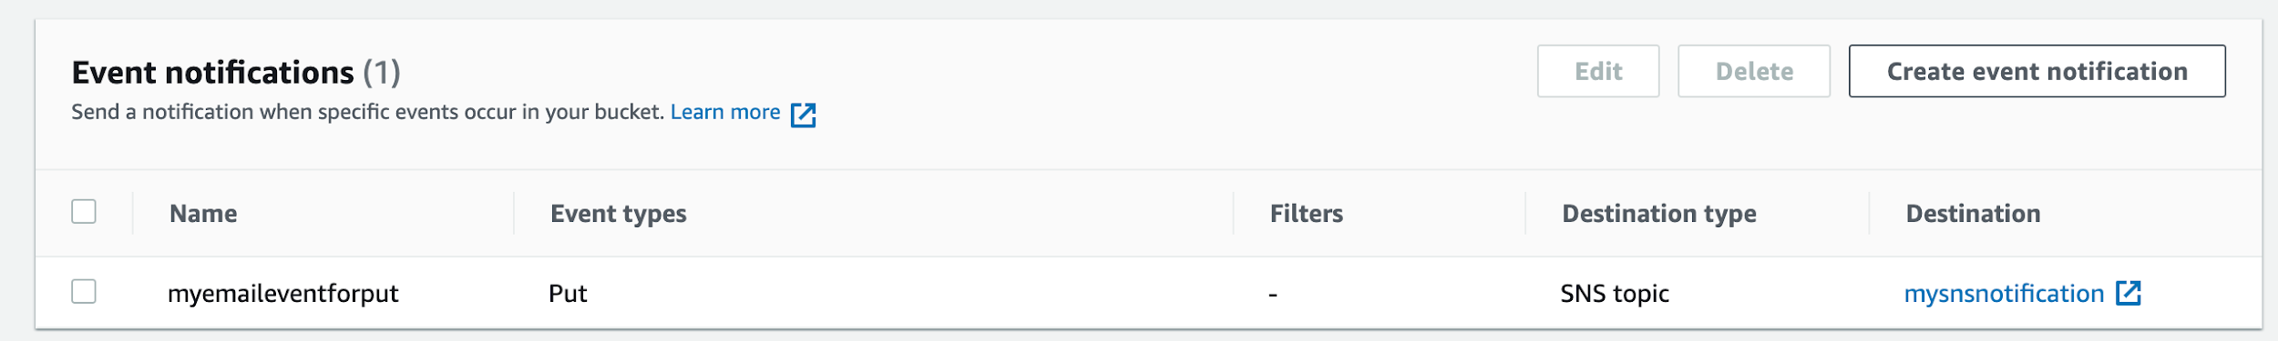

## Task 6: Testing the SNS Notification

1. Open your S3 bucket mys3buckettestingsns*.*
2. In the bucket, under Objects click on Upload
3. Now click on Add Files and upload an image from your local system.
4. Once the image is successfully uploaded to the S3 bucket, click on Close. Now you can see the uploaded image under Objects.  
   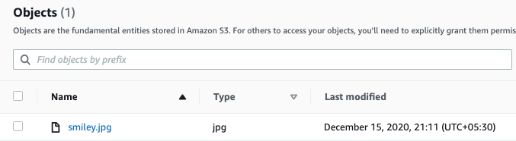
5. You have successfully received a SNS notification based on the PUT object event in S3 bucket.

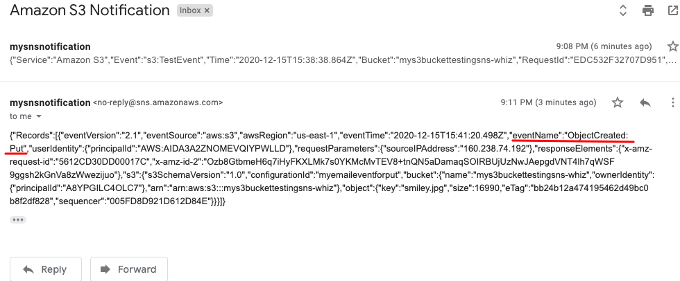

1. Go to your mailbox. You should have received an email from SNS.